Requesting a Web Certificate Using Certificate Signing Request (CSR)

# Submitting CSR

1. Open a browser to either <https://usdcpkiicapd001/certsrv/Default.asp> or <https://usdcpkiicapd002/certsrv/Default.asp> . It is important to remember which one you use as you will have to go to same certificate authority server to check status/retrieve certificates when they are issued.

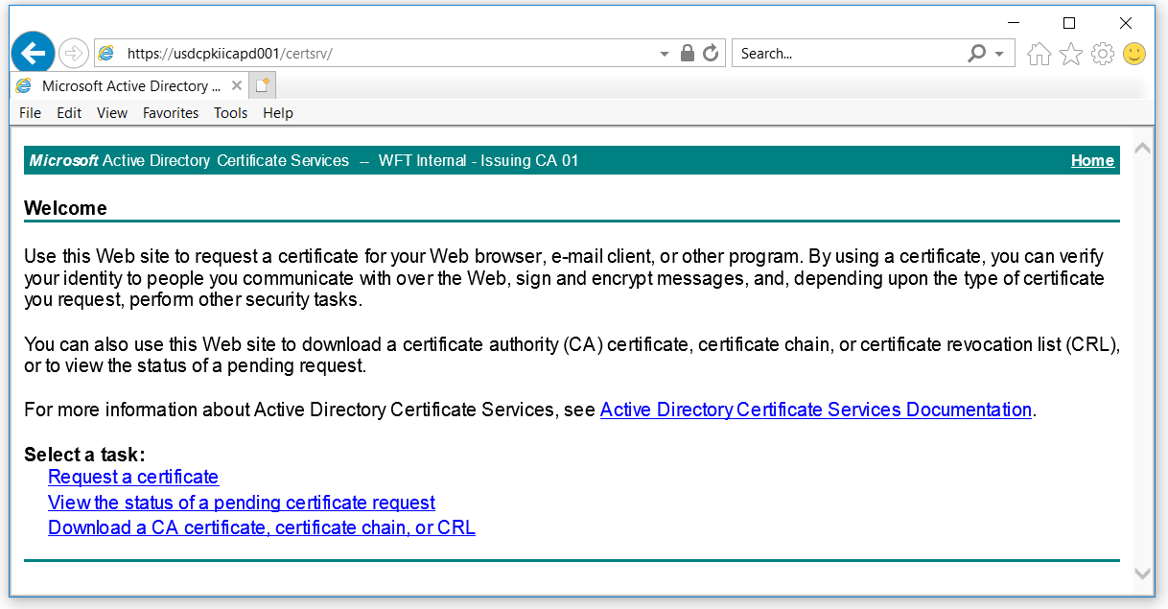

1. Under **Select a Task**, click **Request a certificate.**

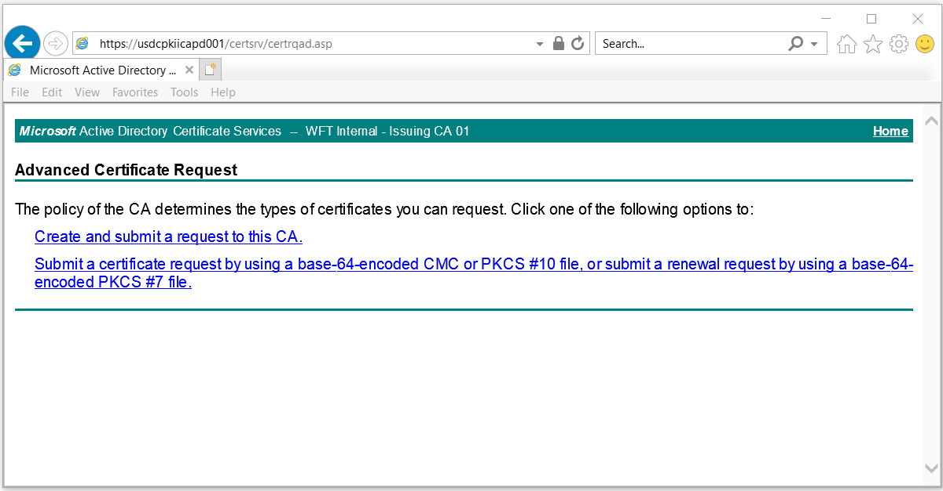

1. Click **Submit a certificate request by using a base-64-encoded CMC or PKCS #10 file, or submit a renewal request by using a base-64-encoded PKCS #7 file.**

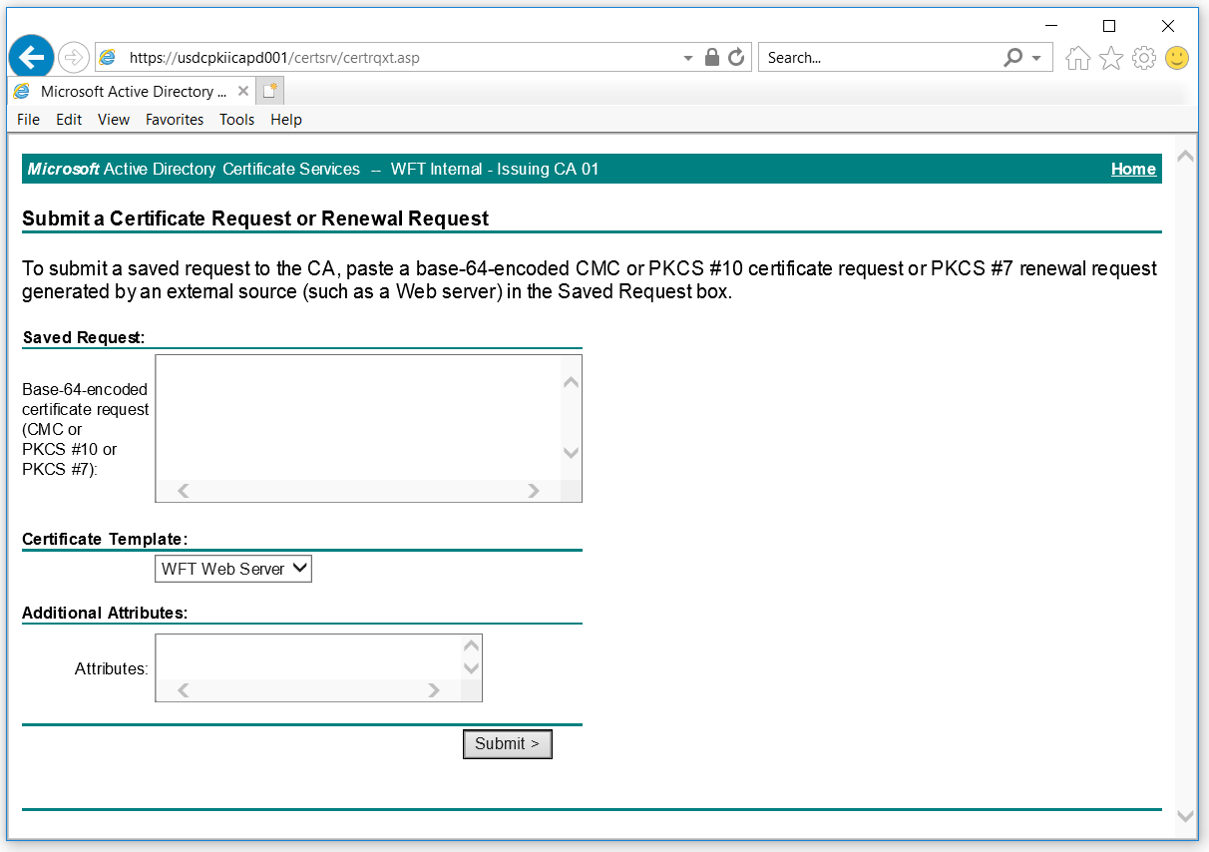

1. Using notepad, open your certificate signing request file and copy the contents into the **Saved Request** area. From the **Certificate Template** drop down, select **WFT Web Server**.

**Note:** Subject alternative names (SAN) entries are no longer being accepted as additional attributes and must be included in the encoded request.

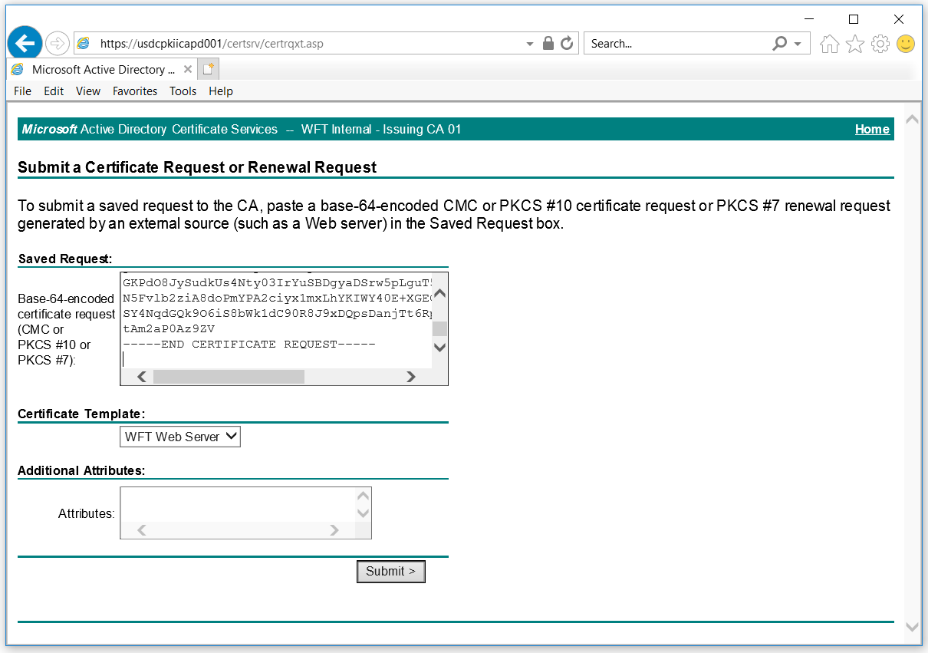

1. **Click Submit**.

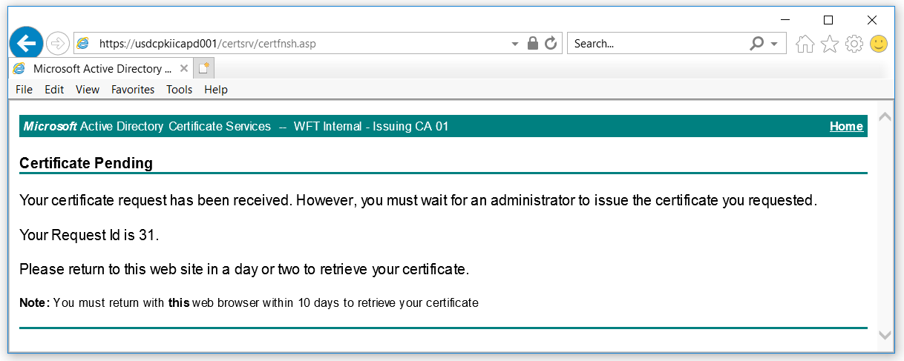

1. Your request has been submitted. The IT Security team will be notified of the pending certificate request automatically via email. The request, specifically the common name and subject alternative names, will be reviewed for appropriateness before certificate issuance. Please allow 48 business hours for your request to be reviewed.

Write down your request Id number (in screen shot 31). This will be helpful in resolving any issues in the event you have trouble locating certificate request.

# Checking Status and Retrieving Issued Certificate

1. Open the same browser from the same computer to the same Certificate Authority server you submitted your CSR to. If you open this site from a different browser/computer or have cleared your browser cache, you will be unable to check status or retrieve approved certificate requests from the web interface. You will need to open a ticket to have the IT Security team manually download your certificate once approved.

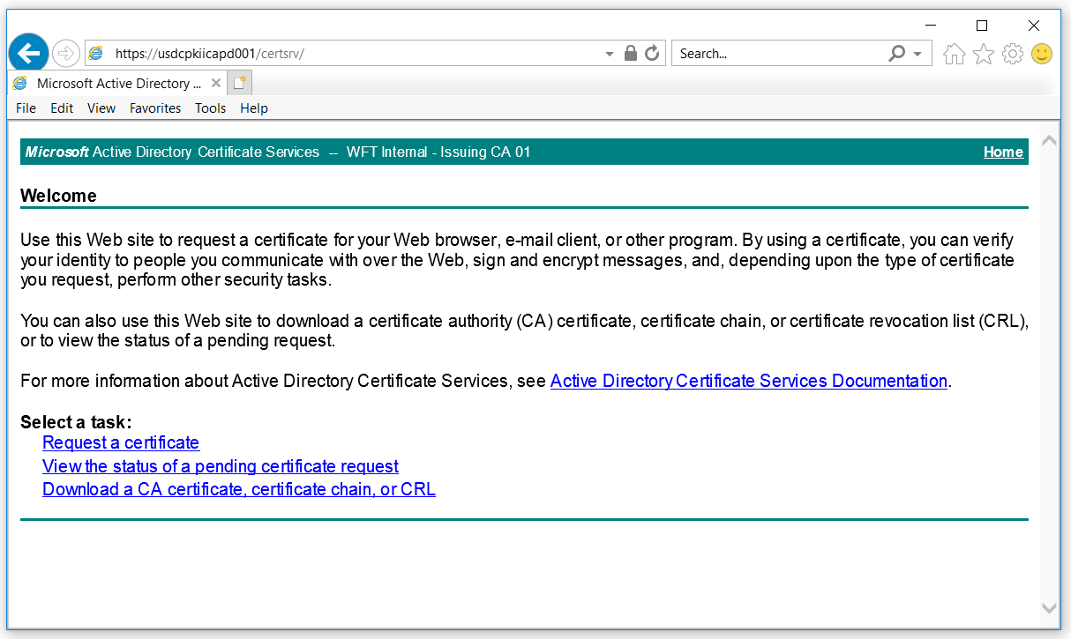

1. Click **View the status of a pending certificate request.**

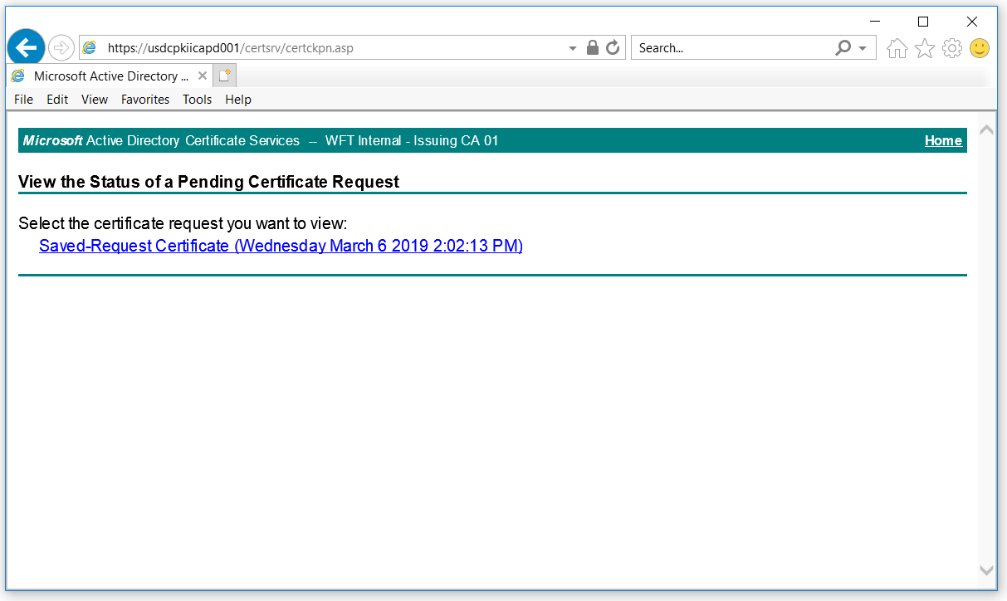

1. You should see any certificates you have requested and not already retrieved. Click the **Saved-Request Certificate …** request you wish to check status on.

If your request is still pending, you will see the following:

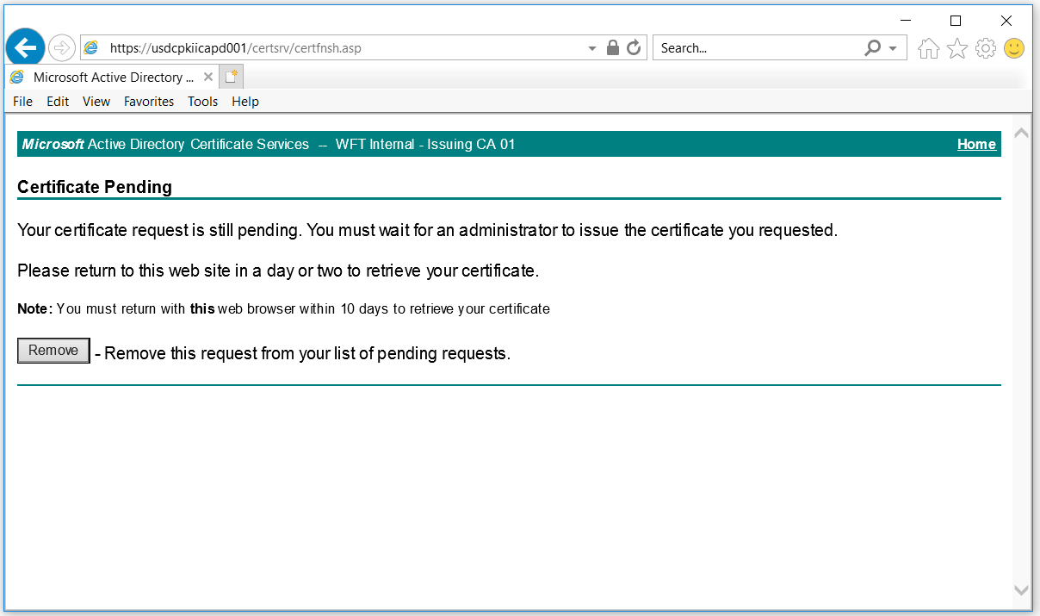

If it has been approved, you will see the following:

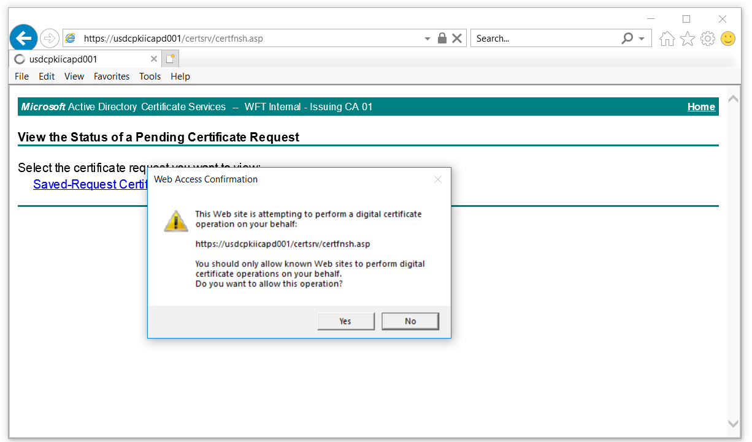

1. You will get a pop-up to confirm that you trust the Certificate Authority server to perform certificate operations. Click **Yes**.

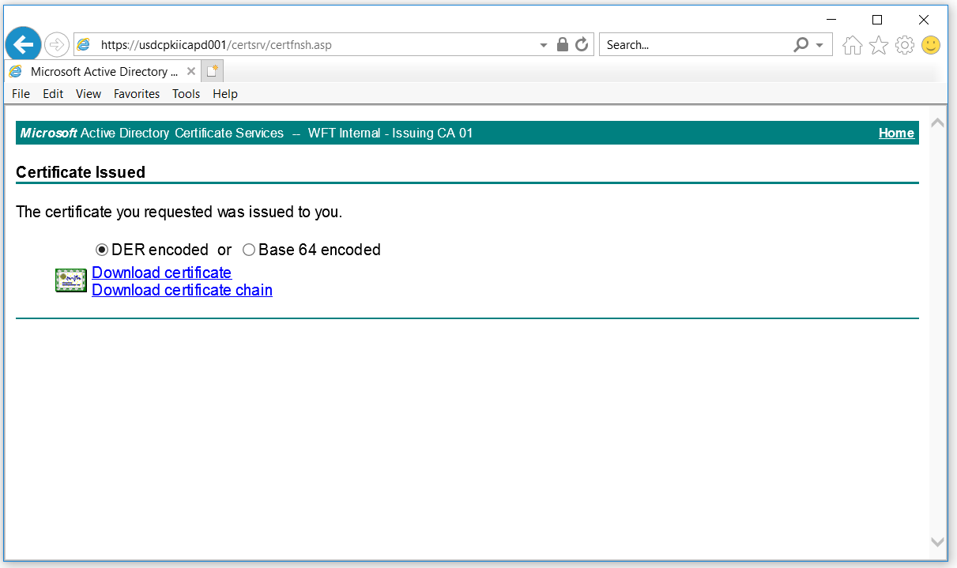

1. Select the format you need (DER or Base 64 encoded) and click either **Download certificate** or **Download certificate chain**. Save the certificate to your computer.

If in doubt, download both formats with and without the certificate chain naming the file accordingly. *Once you leave this page, you will be unable to use the web interface to download the certificate again.*